Problem Statement

By Duran Moodley

# Introduction

A Non-government organization LIVE is in desperate of funds to support their growth and development. They would like an interactive game that can draw the attention of people and other companies to submit donations.

# Program Specification

## Game Description

This game makes use of graphics, user gestures and motion. The aim of the game is to catch the BLUE and GREEN dots has many times as possible in a certain time. When the game starts the user will be shown a black screen. To start, the user will need to drag his/her finger. A Black dot will follow the user’s finger as he/she drags their finger. The user must ensure that he drags the Black dot onto either the Blue or Green dot. Once the user catches the dot a point will be added. The dots will randomly appear on different areas of the screen. 1 Point will be awarded for a Blue dot and 10 Points will be awarded for the Green Dot. However, catching/touching any other dot will result in points being deducted. (Yellow Dot = -10 Points, Red Dot = -1 Point, Gray Dot = -50 Points). This process will continue to occur. Every Level will require a certain amount points to be achieved in order to proceed to the next level. This is your target level points. Successfully achieving these targets points for that level will add on a Bonus 20 points. When the user reaches and successfully completes the last level an additional 50 points will be awarded. The user’s points and scores will be saved to a database and can be viewed on the app. Every user will need to enter in a valid email address for identification. A username will be generated which will keep track of all users playing the game as well as score rankings.

## Functionality

* Graphics
* Drawing on a canvas
* Tracking user gesture and motion
* Saving data to an online MYSQL Database
* Reading a JSON Feed
* Creating and Calling Stored procedures in Awards Space.
* Using Material Design
* Saving/Reading Data from Shared preferences and a text file

## System Requirements

**Main Screen**

*This Screen Contains Game Options for the Player to select. These options include: Play Game, How to Play and World Rankings. This activity also captures the users email address for identification purposes and shows the player their current overall score. This data is saved to a shared preference and sent to the MYSQL online database.*

**Play *Game***

*The player can start the game by selecting this option. You will be shown a Black Screen.*

*Dragging your finger will start the game.*

*When dragging your finger, you will find a Black Dot will follow your finger on the Screen.*

*You need to drag your BLACK Dot onto the BLUE or GREEN Dot that you will see appear on different locations on the screen.*

*You must not to touch the other Dots that Appear.*

*The Points Scheme are as follows:*

*Blue Dot = 1 Point*

*Green Dot = 10 Points;*

*Yellow Dot = -10 Points;*

*Red Dot = -1 Point;*

*Gray Dot = -50 Points;*

*At the start you will get a Target of Points to get.*

*If you successfully get the specified Target Points for that Level, You will get a Bonus 20 Points.*

*Successfully Completing the Last Level will Award you an Extra 50 Points.*

*The players score is accumulated after every level. This data will eventually update the players overall score tally in the MYSQL online database.*

**How to Play**

*Data is retrieved from a text file which gives instructions of how to play the game.*

**World Rankings**

*Data is retrieve from a MYSQL database. This contains the positions of everyone who’s playing the game. The player’s username, positions and score is shown in a list view.*

**About LIV**

*Data is retrieve from a text file which gives details about LIV and what they stand for as an NGO. A Floating action bar can be used to redirect to the web page of LIV by simply clicking on it.*

**Donate**

*Data is retrieved from a text file which gives instructions of how to donate and what methods a user can use. A Floating action bar can be used to redirect to the web page of LIV by simply clicking on it.*

**Volunteer Your Skills**

*This provides information of how to become a volunteer and what skills be used. A Floating action bar can be used to redirect to the web page of LIV by simply clicking on it.*

**Corporate Team Building**

*Gives information how the social investment opportunity that LIV provides. A Floating action bar can be used to redirect to the web page of LIV by simply clicking on it.*

**Get in Touch**

*Give details of how to contact the organisation and the address. A Floating action bar can be used to redirect to their face book page.*

**Screenshots**

*Dialog to enter email address*

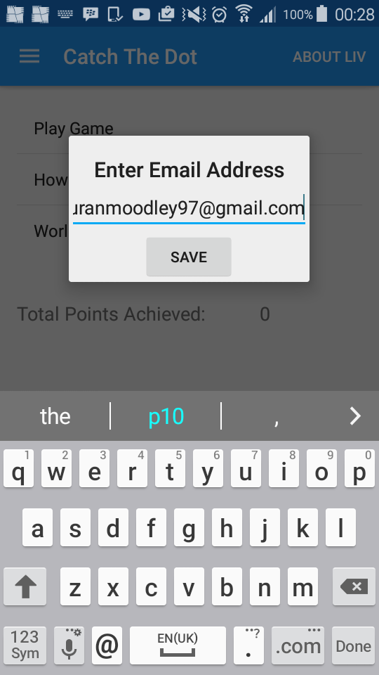

*Validating the input data*

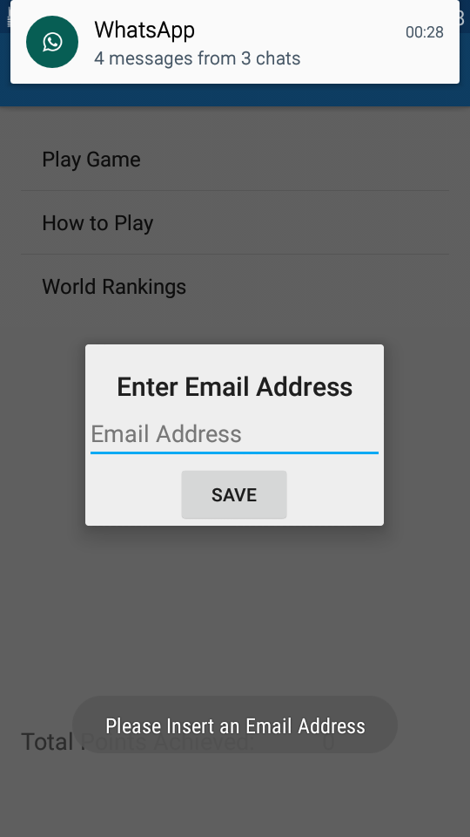

Menu Screen showing Game Options Navigation Menu

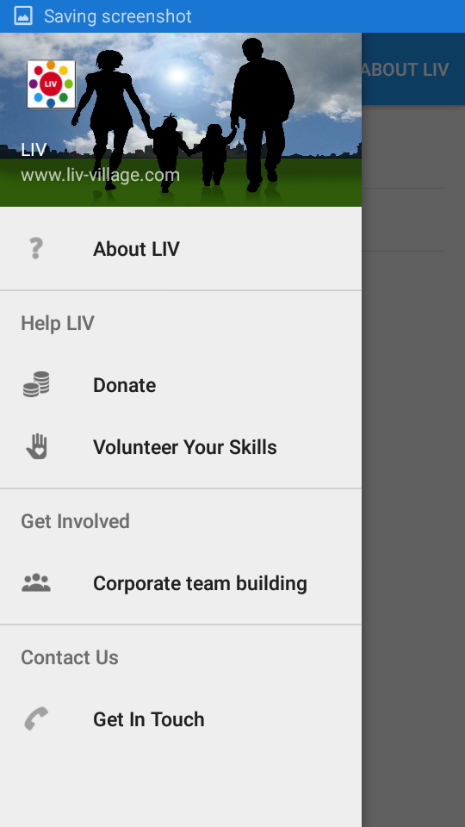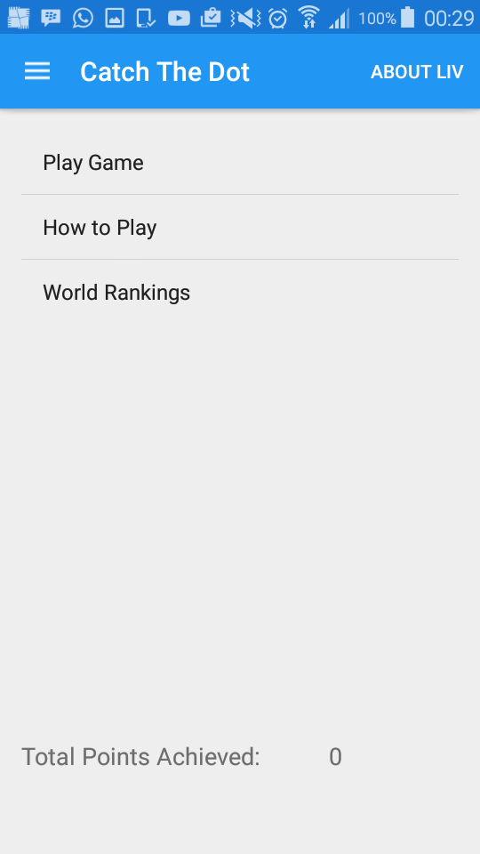

Showing Data of How to Play Showing Data About LIV

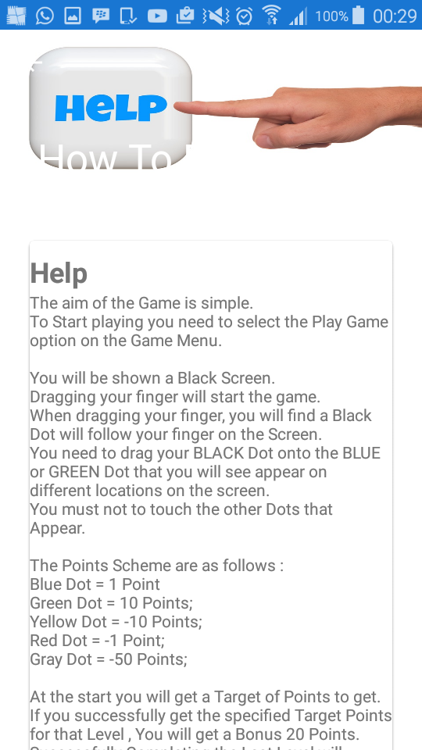

Showing donation Information Showing Volunteer Details

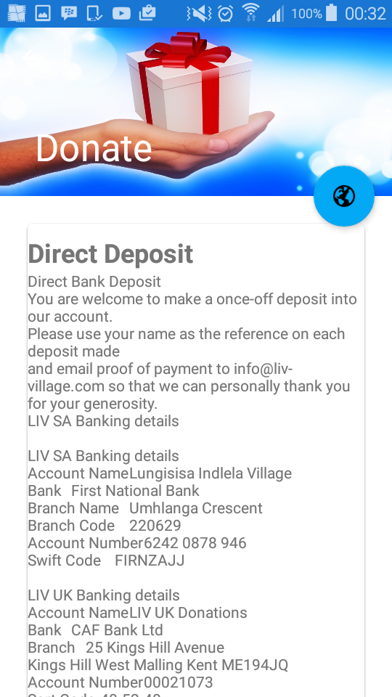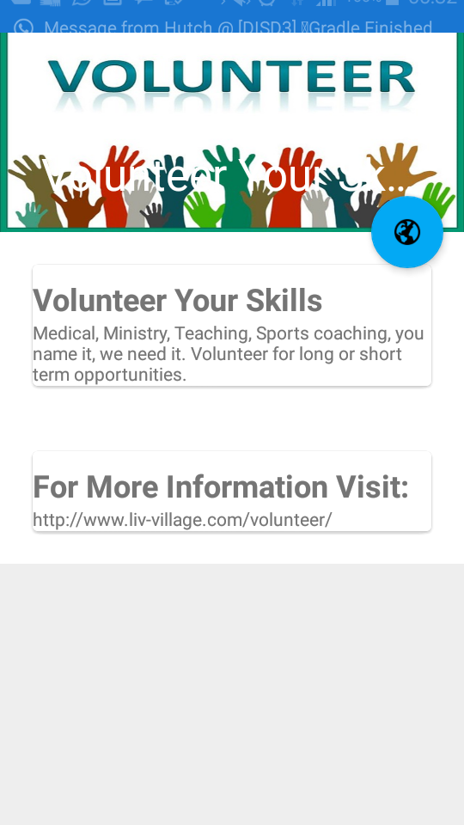

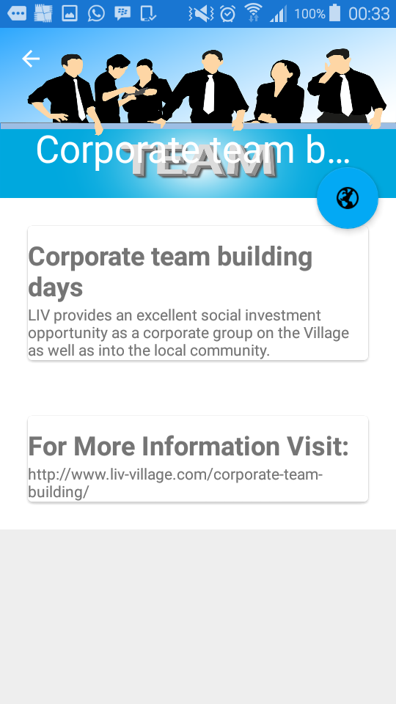

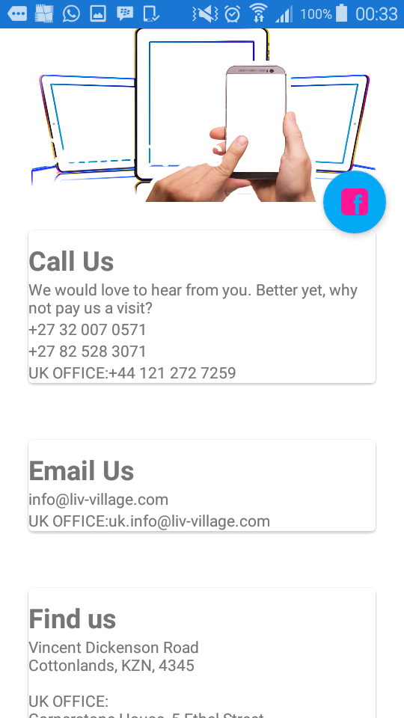Showing Team Building information Showing Contact Information

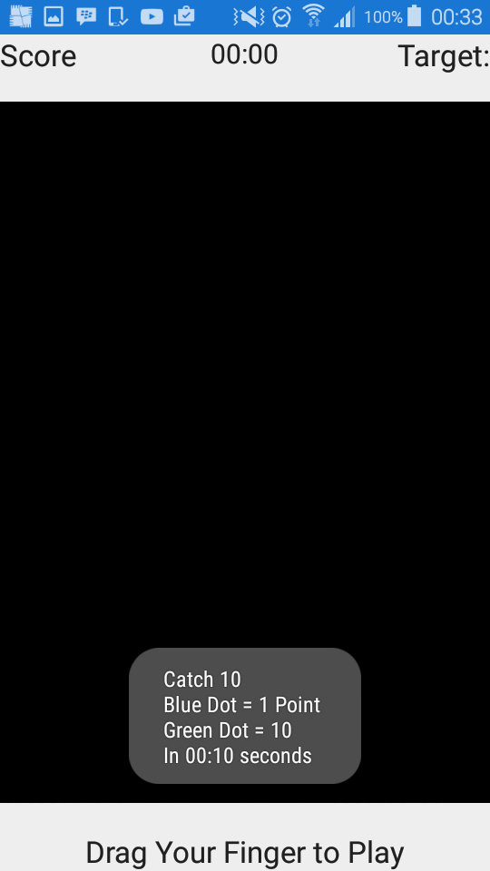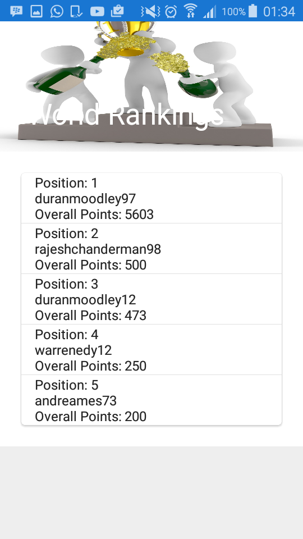Showing the scores and rankings of all players Game Start Screen

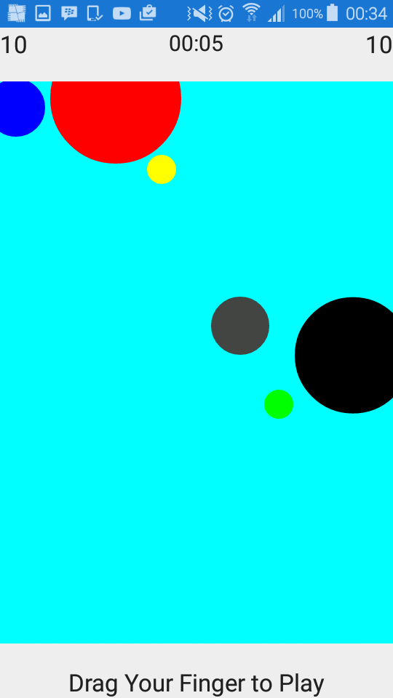

Game Has Started. Player has touched the correct Dot. The Score has been updated by 10 points, has seen on the top left hand side of the screen. The Black Dot follows/tracks the user finger as he/she moves across the screen.

Player has won the Level by meeting the target points for that Level.

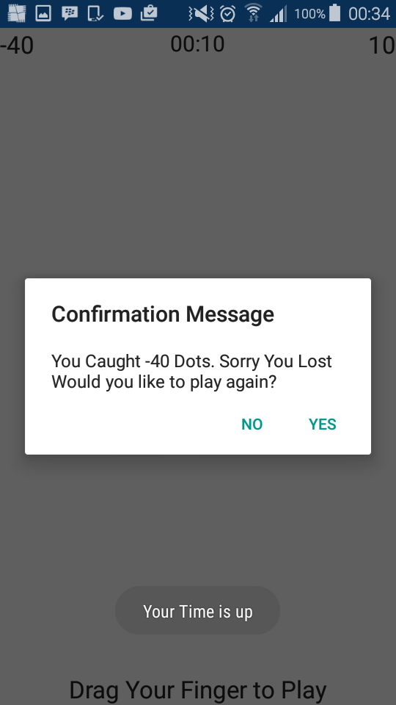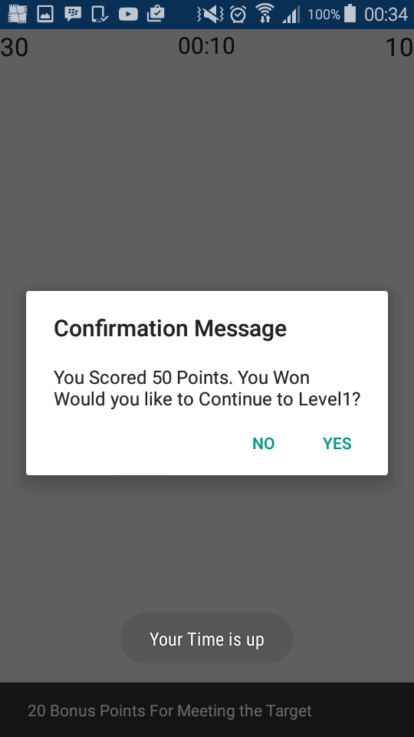A Bonus 20 Points has been awarded. Player has lost. Target not met

Final Level Target has been reached. A Bonus 50 Points has been awarded

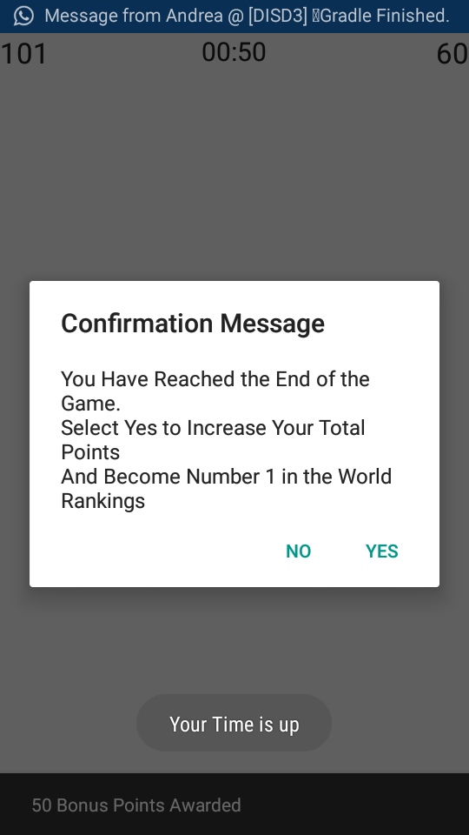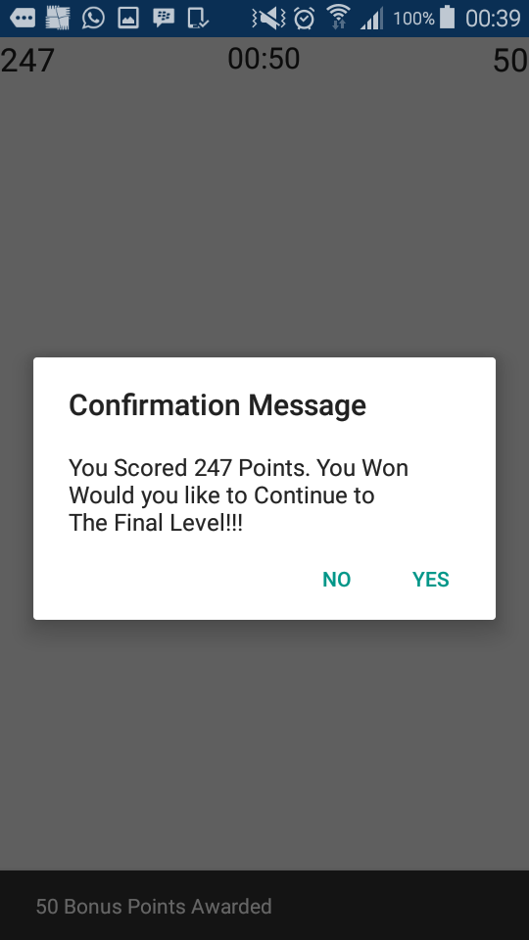All Levels Complete. Confirmation Message

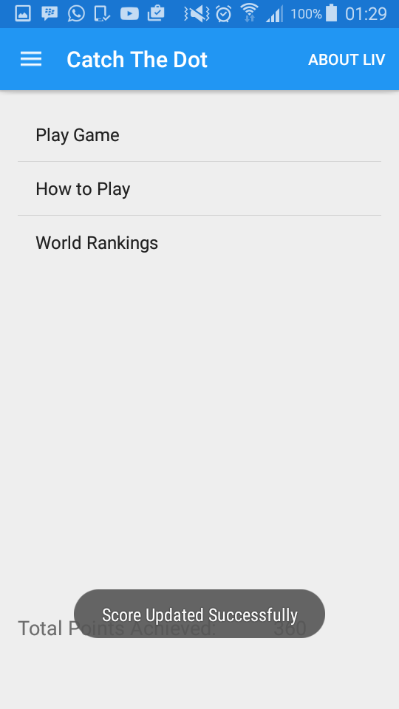 Total Score Updated on MYSQL online Database